**ITS 26000 – Applied Database Tech**

**Lab 09 – (100 points)**

**Use SQL to complete the following exercises.**

### **KimTay Pet Supplies:**

* 1. In textbook,LEVEL1_CUSTOMER table is created (Figure 6-1), then the data from Customer table is added into LEVEL1_CUSTOMER (Figure 6-2), in which two statements are executed. Can you just use one statement to implement the same task? List your command and the screenshot of the result. (15 points)

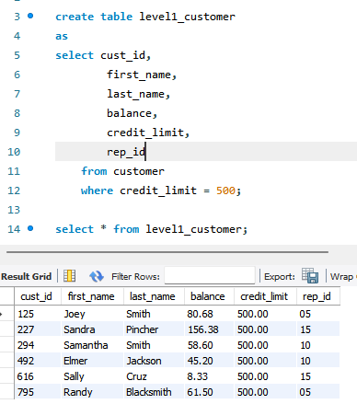

create table level1_customer

as

select cust_id,

first_name,

last_name,

balance,

credit_limit,

rep_id

from customer

where credit_limit = 500;

* 1. Create a NONCAT table with the structure shown in Figure 6-28 (15 points)

create table noncat (

item_id char(4) not null primary key,

description char(30),

on_hand decimal(4,0),

category char(3),

price decimal(6,2)

);

* 1. Insert into the NONCAT table the item ID, description, number of units on hand, category, and unit price from the ITEM table for each item that is not in category CAT. (10 points)

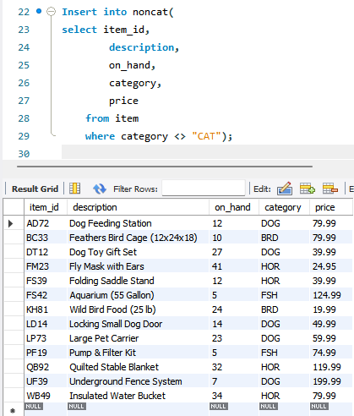

Insert into noncat(

select item_id,

description,

on_hand,

category,

price

from item

where category <> "CAT");

* 1. In the NONCAT table, increase the price of each item in category BRD by five percent. (Hint: Multiply each price by 1.05.) (10 points)

Before :

update noncat

set price = price * 1.05

where category = "BRD";

After :

update noncat

set price = price * 1.05

where category = "BRD";

* 1. In the NONCAT table, change the category for item UF39 to null. (10 points)

Before :



update noncat

set category = null

where item_id = "UF39";

After :

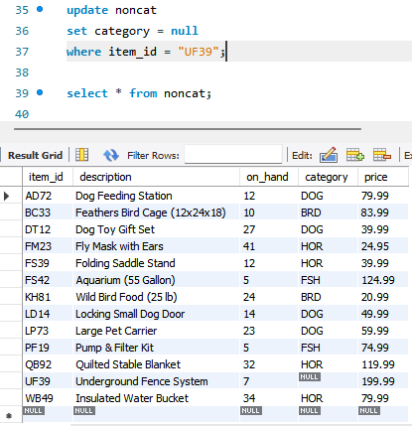

* 1. Add a column named ON_HAND_VALUE to the NONCAT table. The on-hand value is a seven-digit number with two decimal places that represents the product of the number of units on hand and the price. Then set all values of ON_HAND_VALUE to ON_HAND * PRICE. (10 points)

alter table noncat

add on_hand_value decimal(7,2);

update noncat

set on_hand_value = price * on_hand;

* 1. In the NONCAT table, increase the length of the DESCRIPTION column to 40 characters. (10 points)

Before :

alter table noncat

modify description char(40);

After:

* 1. Remove the NONCAT table from the KimTay Pet Supplies database. (10 points)

Before :

drop table noncat;

After:

* 1. Write the SQL command to delete the ON_HAND_VALUE column from the NONCAT table. (10 points)

Before:

alter table noncat

drop column on_hand_value;

After:

**Deliverables**: **Document Report with the SQL statement/Query and snapshot of query, its execution and results.** Either word or pdf file need to be uploaded into Brightspace in one submission